

For Perfect Kits to Fit Your Needs

* TLS Detox Kit

*Process Food/Poor Digestion*

* TLS 30 Day Jump Start Kit

*To Jump Start Weight Loss Journey*

**TLS Stay Fit Kit Contain:**

1. TLS Nutrition Shake (Chocolate & Vanilla) (14 Servings)

1 NutriClean 7 days Cleanse

1 TLS CORE ( 30 Servings)

1. Isotonix Daily Essential Kit ( 30 Packet)

1 TLS 30 Day Jump Start booklet

1 TLS 30 Day Jump Start Menu Plan  
 1 TLS 30 Day Workout Booklet

**TLS Detox Kit Contain:**

1 NutriClean 7 days Cleanse  
1 TLS CORE

1 Isotonix Multivitamin (30 servings)

1 Isotonix OPC-3 (30 servings)

**COST | $176.65**

* Fast Start Kit

*Become an Entrepreneur And begin creating on going income*

**COST | $199.00**

* TLS Stay Fit Kit

*To stay the Course and stay fit.*

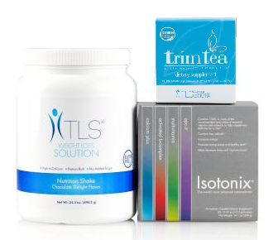

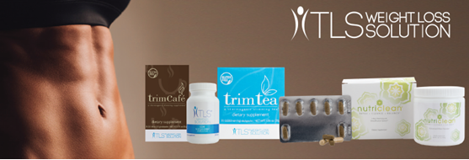

**COST | SGD $575.00**

**TLS Stay Fit Kit Contain:**

1 Isotonix Complete B Complex (90 servings)

1 TLS Nutrition Shake (Chocolate or Vanilla) (14 Servings)

1. Isotonix Daily Essential Packet (30 packets)

**COST | $149.95**

Credit Card Purchasing Option:

Name______________________________ Phone ___________

Address _____________________________________________

City _________________________State _____ Zip ___________

Email ________________________________________________

Card Number ____________________ Exp Date(MM/YY)______

Signature _____________________________________________

**For optimum wellness take advantage of the auto shipment option and save an additional 5% discount?**

**Yes __ / No__**